Clare Llewellyn
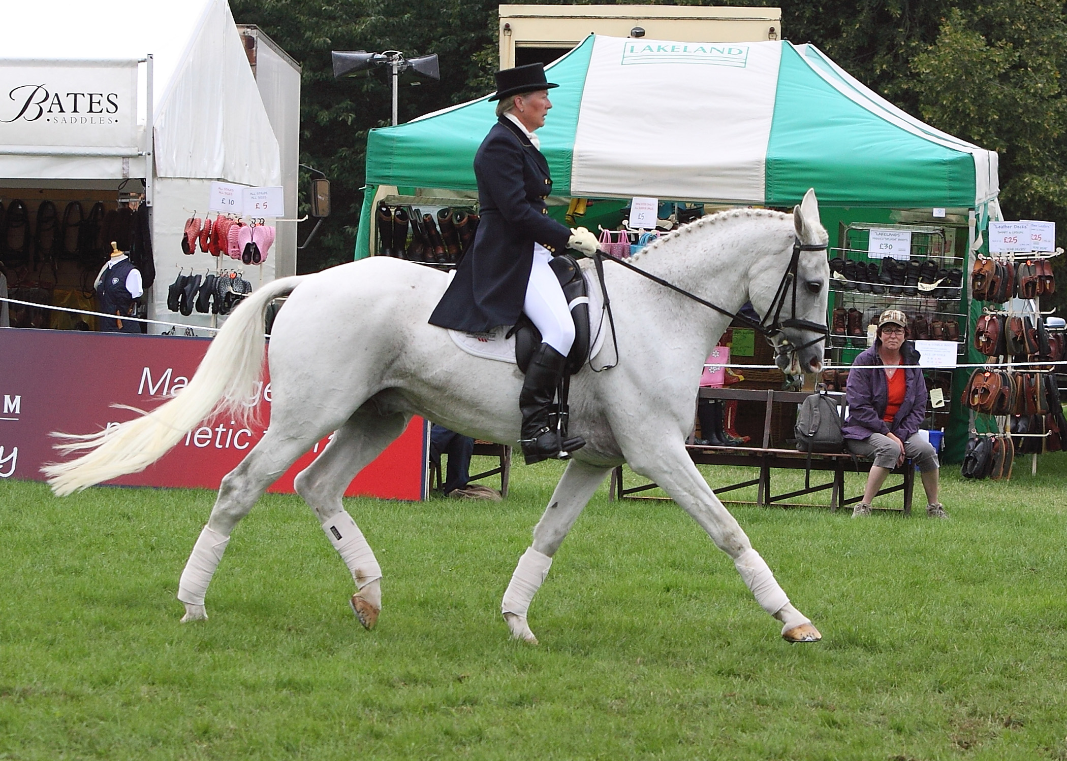
Clare completed her BHSII exams and went to explore more of the horse world, spending 2 years with a BS training yard where she was regularly involved in both team chasing and hunting. She then became yard manager at an eventing yard before a 9 year spell as yard manager to the MacConnal Mason Eventing Team,
Riding Shear H₂0 at Blenheim International 3 day event, 2010 doing a dressage to music demo. Photo courtesy of Fiona Scott Maxwell

travelling throughout England and Europe covering events and organising a team of event horses from novice to 4* competitions.
After marriage, children and a quiet period, she then started teaching again and in 2001 was given the ride on retired eventer Harbinger, (formley the ride of Tina Cook) with whom she successfully competed in dressage and showing, culminating as a reserve champion at the Veteran Horse Society Champs at Olympia. In 2005, she took over the ride on Shear H₂0, when Leslie Law relocated to USA and they competed in BD, qualifying for many regional championships, and performing a very successful dressage to music demo at the 2010 Blenheim 3 day event. She very much enjoys teaching all levels and in particular, specialises in pole-work for dressage fans to show them how much use poles can used be even for the dedicated ‘feet on the floor rider’.

