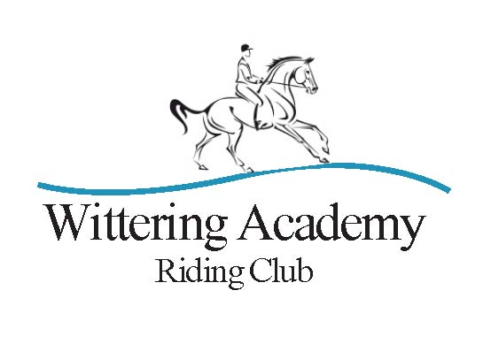

Achieve your equestrian dreams – one hoof at a time

UNAFFLIATED DRESSAGE COMPETITION
BRC MEMBERS ONLY – QUALIFIER FOR WARC CHAMPIONSHIP
CLASSES AT OUR MAY COMPETITION
SUNDAY 12TH OCTOBER 2025
AT
GRANGE FARM EQUESTRIAN CENTRE, WITTERING, NEAR STAMFORD
By kind permission of Mr and Mrs R Dunlop

Class 1 Intro 1 (2024) Open/Restricted * Restricted section is for horse & rider combinations who have not been placed 1st or 2ndat this level. Please state on your entry form if Restricted or Open section.
Class 2 Intro 2 (2024)

Class 3 Prelim 1 (2024) Open/Restricted * Restricted section is for horse & rider combinations who have not been placed 1st or 2ndat this level. Please state on your entry form if Restricted or Open section.
Class 4 Prelim 2 (2024)

Class 5 Novice 1 (2024)

Class 6 Novice 2 (2024)

Class 7 PYO – Novice 3 (2024)/Elementary 1 (2024)/ Elementary 3 (2024)
More than one test can be ridden; Please state on entry form the test(s) you would like to ride

ROSETTES: To 6th Place (Rosette to best junior in each class if not placed)
ENTRY FEES: £13 Members & Other BRC riding club members (please note on entry form); £17 Non-members; Late entries £3 extra if space. Please consider becoming a member if you would like to be included in the championship classes https://www.witteringacademy.com/how-to-join/
ENTRIES: ONLINE ENTRIES ONLY via the link on the competitions page at www.witteringacademy.com
Please note the non-refundable admin charge of £1.50. NO NUMBERS PROVIDED; please use 2 bridle or saddle numbers or a bib.

CLOSING DATE: Sunday 5th October (Late entries until Tuesday 7th if space)
TIMES: Times will be available on www.witteringacademy.com and Facebook from Thursday 9th October, 8pm and through the online entry link

Classes will start at 9.30 although we retain the right to alter this due to weather conditions

All classes and warm-up are on all weather surfaces

CONTACT: Janice Price 07948 401223

PLEASE ENSURE ALL DROPPINGS AND HAY ARE REMOVED FROM THE LORRY PARK

WINTER MEMBERS’ QUALFICATION RULES:

A qualifying score is 62% or above.

A qualifying score enables that combination to enter the ‘Championship’ section of that level (eg Prelim/novice) at the WARC competition on May 16, 2026.

Riders are encouraged to move up or down the levels throughout the series as appropriate for their combination but may only compete in one Championship section at the May competition.

There will be separate Championship sections for Juniors

Attendance is subject to the COVID-19 restrictions at the time and all participants must adhere to the WARC COVID-19 guidance. PLEASE DO NOT ATTEND IF YOU ARE FEELING UNWELL • Ensure you park a safe distance from others. • Practice social distancing while spectating and purchasing/eating refreshments • Do not go onto the Livery Yard area (unless to use the facilities)

This competition will be run under Wittering Academy Riding Club rules (hard hats with chin straps are required), entry into the event signifies acceptance of the rules (copy on website). Entry also signifies agreement to be photographed by the official photographer(s) if present. All reasonable precautions taken regarding Health and Safety, but WARC accept no liability for any loss, damage or accident to persons, animals or property however caused.
Non BRC or PC members should ensure they have valid insurance to cover both themselves and their mounts.
Your Personal Information that you supply to us may be used in several ways to facilitate your WARC event participation. It should be noted that we are affiliated to the British Horse Society as a British Riding Club. We reserve the right to publish results of competitions on www.witteringacademy.com and in WARC newsletters. To see our full Privacy Policy, or if you need any further information, please write to us or go to www.witteringacademy.com

